Table of Contents
Table of Contents i
List of Figures iv
List of Abbreviations v
Abstract vi
1. Introduction 1
1.1 Description 1
1.2 Problem statement 2
1.3 Scope and Motivation 3
1.4 Project Objectives 4
2. Literature Review 5
2.1 Literature Survey Papers 5
2.2 Existing System 8
2.3 Proposed System 13
3. Requirement Analysis and Planning 16
3.1 Functional Requirement 16
3.2 Nonfunctional requirements 16
3.2.1 Performance 16
3.2.2 Reliability 17
3.2.3 Availability 17
3.3 System requirements 17
3.3.1 Hardware requirements 17
3.3.2 Software requirements 17
3.4 Project Planning 18
3.4.1 Timeline Project 18
3.4.2 Task distribution 19
4. Analysis Modeling 20
4.1.1 Use Case Diagram 20
4.1.2 Sequence Diagram 22
4.1.3 Activity Diagram 24
4.1.4 State Chart Diagram 26
4.2 Data Flow Diagram 27
4.2.1 DFD - Level 0 27
4.2.2 DFD - Level 1 27
4.2.3 DFD - Level 2 29
4.3Database Design 30
4.3.1 ER Diagram 30
5. System Design 32
5.1 Application Architecture 32
5.2Class Diagram 33
5.3Object Diagram 34
5.4 Collaboration Diagram 35
5.5 Component Diagram 36
5.6 Deployment Diagram 37
5.7 Graphical User Interface 38
6. Implementation 41
6.1 Using Twitter4j 41
6.2 Extracting Tweets on Specific Topic 42
7. Results 43
8. Conclusion 45
9. References 46

List of Tables

Table 3-1 Project Timeline Phase -1 18
Table 3-2 Project Timeline Phase - 2 19
Table 3-3 Task Distribution 19

List of Figures
Figure 2.3 Flowchart ..............................................................................................................................15
Figure 4.1 Use case .............................................................................................................................. 22
Figure 4.2 Sequence Diagram .............................................................................................................. 23
Figure 4.3 Activity Diagram ................................................................................................................ 25
Figure 4.4 State Chart .......................................................................................................................... 27
Figure 4.5 DFD of Level 0......................................................................................................................28
Figure 4.6 DFD of Level 1......................................................................................................................29
Figure 4.7 DFD of Level 2......................................................................................................................30
Figure 4.8 ER Diagram............................................................................................................................31
Figure 5.1 Application Architecture........................................................................................................32
Figure 5.2 Class Diagram.........................................................................................................................33
Figure 5.3 Object Diagram.......................................................................................................................34
Figure 5.4 Collaboration Diagram...........................................................................................................35
Figure 5.5 Deployment Diagram... .........................................................................................................36

List of Abbreviations

ANN | Artificial Neural Network
ER | Entity Relationship
ML | Machine Learning

Abstract

With the rise of social networking epoch, there has been a surge of user generated content. Micro blogging sites have millions of people sharing their thoughts daily because of its characteristic short and simple manner of expression. We propose and investigate a paradigm to mine the sentiment from a popular real-time micro blogging service, Twitter, where users post real time reactions to and opinions about “everything”. Social networking sites like twitter, Facebook, etc. are the great source of communication for internet users. So these become an important source for understanding the opinions, views or emotions of people. We extract data, i.e. tweets from Twitter in real time and apply machine learning techniques to convert them into a useful form and then use it for building sentiment classifier. Given a piece of written text, the problem is to categorize the text into one specific sentiment polarity i.e. positive, negative or neutral.

Introduction

Here we will elaborate the aspects like description, problem statement, scope, motivation and also the objectives of our project

Description
Sentiment is an attitude, thought, or judgment prompted by feeling. Sentiment analysis, which is also known as opinion mining, studies people’s sentiments towards certain entities. Internet is a resourceful place with respect to sentiment information. From a user’s perspective, people are able to post their own content through various social media, such as forums, micro-blogs, or online social networking sites. From a researcher’s perspective, many social media sites release their application programming interfaces (APIs), prompting data collection and analysis by researchers and developers. For instance, Twitter currently has three different versions of APIs available, namely the REST API, the Search API, and the Streaming API. With the REST API, developers are able to gather status data and user information; the Search API allows developers to query specific Twitter content, whereas the Streaming API is able to collect Twitter content in real time. Moreover, developers can mix those APIs to create their own applications. Hence, sentiment analysis seems having a strong fundament with the support of massive online data. However, those types of online data have several flaws that potentially hinder the process of sentiment analysis. The first flaw is that since people can freely post their own content, the quality of their opinions cannot be guaranteed. For example, instead of sharing topic-related opinions, online spammers post spam on forums. Some spams are meaningless at all, while others have irrelevant opinions also known as fake opinions. The second flaw is that ground truth of such online data is not always available. A ground truth is more like a tag of a certain opinion, indicating whether the opinion is positive, negative, or neutral. The Stanford Sentiment 140 Tweet Corpus [10] is one of the datasets that has ground truth and is also public available. The corpus contains 1.6 million machine-tagged Twitter messages.
Microblogging websites have evolved to become a source of varied kind of information. This is due to nature of micro blogs on which people post real time messages about their opinions on a variety of topics, discuss current issues, 2 complain, and express positive sentiment for products they use in daily life. In fact, companies manufacturing such products have started to poll these microblogs to get a sense of general sentiment for their product. Many time these companies study user reactions and reply to users on microblogs. One challenge is to build technology to detect and summarize an overall sentiment. Our project analyzes tweets by the peoples on certain products of companies or brands or performed by political leaders. In order to do this we analyzed tweets from Twitter. Tweets are a reliable source of information mainly because people tweet about anything and everything they do including buying new products and reviewing them.

Problem statement
Despite the availability of software to extract data regarding a person’s sentiment on a specific product or service, organizations still face issues regarding the data extraction. With the rapid growth of the World Wide Web, people are using social media such as Twitter which generates big volumes of opinion texts in the form of tweets which is available for the sentiment analysis. This allows a huge volume of information from a human viewpoint which makes it difficult to extract sentences, read them, analyses them tweet by tweet, summarize them and organize them into an understandable format in a timely manner.
Informal language refers to the use of colloquialisms and slang in communication, employing the conventions of spoken language such as ‘would not’ and ‘wouldn’t’. Not all systems are able to detect sentiment from use of informal language and this could create a problem for the analysis and decision-making process. Emoticons are a pictorial representation of human facial expressions, which in the absence of body language serve to draw receiver's attention to the tenor or temper of a sender's nominal verbal communication, improving and changing its interpretation.
For example, ☺ indicates a happy state of mind and 😞 indicates a sad state of mind. Systems currently in place do not have sufficient data to allow them to draw feelings out of the emoticons. As humans often started using emoticons to properly express what they cannot put into words. Short-form is widely used even with short message service (SMS). The usage of short-form will be used more frequently on Twitter so as to help to minimize the characters used. This is because Twitter has put a limit on its characters to 140.
Sentiment analysis has turned out as an exciting new trend in social media with a large amount of practical applications that range from applications in business to government use. Sentiment is an attitude, thought, or judgment prompted by feeling. Sentiment analysis is also known as opinion mining. Sentiment Analysis is used to classify the reviews using the sentiment of the words into positive or negative. Using the sentiment expressed in the words, opinions on any entity can be categorized into positive or negative. For example, the sentence, ‘I am not excited by this product though it is quite cheap’ expresses a negative sentiment about the product.

Scope and Motivation
We have chosen to work with twitter since we feel it is a better approximation of public sentiment as opposed to conventional internet articles and web blogs. The reason is that the amount of relevant data is much larger for twitter, as compared to traditional blogging sites. Moreover, the response on twitter is more prompt and also more general (since the number of users who tweet is substantially more than those who write web blogs on a daily basis). This could be done by analysing overall public sentiment towards that firm with respect to time and using economics tools for finding the public sentiment. Firms can also estimate how well their product is responding in the market, which areas of the market is it having a favourable response and in which a negative response.

Project Objectives

Sentiment classification is a way to analyze the subjective information in the text and then determine the opinion. Sentiment analysis is the procedure by which information is extracted from the opinions, appraisals and emotions of people in regards to entities, events and their attributes. In decision making, the opinions of others have a significant effect on customer’s ease, making choices with regards to online shopping, choosing events, products, entities.
The objective of this project is to show how sentimental analysis can be used to recognize user’s mood or emotion using tweets which has been extracted in real time. The learning algorithm will then learn what our emotions are from statistical data then determine the emotion.

2. Literature Review
Here we will elaborate the aspects like the literature survey of the project and what all projects are existing and been actually used in the market which the makers of this project took the inspiration from and thus decided to go ahead with the project covering with the problem statement.

Literature Survey Papers
SR NO. | YEAR &AUTHOR | TITLE | ABSTRACT
1. | 2014  Sameesksha Shrivastava,  Dr. Pramod S. Nair | Mood Prediction on Tweets Using Classification Algorithm | In this the authors uses identified twitter data set which is used to perform text analysis. Therefore the entire input data samples are required to classify in two classes namely positive and negative. Therefore in this paper a binary classifier namely ID3 decision tree and their improved variant is utilized for analysis and performing the classification task.
2. | 2015  Akshi Kumar,  Prakhar Dogra  and Vikrant Dabas3 | Emotion Analysis of Twitter using Opinion Mining | In this author intend to categorize the opinion on the basis of five emotions, namely Happiness, Anger, Fear, Sadness & Disgust, which have been globally accepted & defined in human psychology. A two-step approach is proposed, to identify the sentiment; extract the opinion words (a combination of the adjectives along with the verbs and adverbs) in the tweets and subsequently use a novel algorithm to find the emotion values of opinion words.
3. | 2017  Abu Zonayed Riyadh,  Nasif Alvi,  Kamrul Hasan Talukder. | Exploring Human Emotion via Twitter | In this authors have mainly focused on feature extraction for the purpose of classification and feature extraction depends on the perfection of pre-processing of a tweet. The pre-processing is the most difficult task, since it can be done in various ways and the methods or steps applied in pre-processing are not distinct. Most of the researches in this topic have been focused on binary (positive and negative) and 3-way (positive, negative and neutral) classifications. In this paper, authors have focused on emotion classification of tweets as multi-class classification. They have chosen basic human emotions (happiness, sadness, surprise, disgust) and neutral as emotion classes..
4. | 2012  Aksi kumar,  Teeja Mary Sebastian | Sentiment Analysis on Twitter Data | In this paper, authors expound a hybrid approach using both corpus based and dictionary based methods to determine the semantic orientation of the opinion words in tweets. A case study is presented to illustrate the use and effectiveness of the proposed system.
5. | 2013  Seyed-Ali Bahrainian, Andreas Dengel | Sentiment Analysis and Summarization of Twitter Data | This paper introduces a novel solution to target-oriented sentiment summarization and SA of short informal texts with a main focus on Twitter posts known as “tweets”. Authors compare different algorithms and methods for SA polarity detection and sentiment summarization. They shows that hybrid polarity detection system not only outperforms the unigram state-of-the-art baseline, but also could be an advantage over other methods when used as a part of a sentiment summarization system.
6. | 2013  M S Neethu,  R Rajasree | Sentiment analysis in twitter using machine learning techniques | In this paper, authors try to analyze the  twitter posts about electronic products like mobiles, laptops etc using Machine Learning approach. By doing sentiment analysis  in a specific domain, it is possible to identify the effect of domain information in sentiment classification. Authors present a new feature  vector for classifying the tweets as positive, negative and extract peoples’ opinion about products. Techniques like Nave Bayes, SVM Classifier, Maximum Entropy, Ensemble classifier authors have used.
7. | 2015  Brett Duncan and Yanqing Zhang | Neural Networks for Sentiment Analysis on Twitter | Sentiment analysis can be used to find out the polarity of an opinion, such as positive, negative, or neutral. Sentiment analysis has applications such as companies getting their customer's opinions on their products, political sentiment analysis, or opinions on movie reviews. In this paper, a feedforward Neural Network is used to classify the text as being positive, negative, or neutral.
8. | 2013  Olivier Janssens, Maarten Slembrouck, Steven Verstockt, Sofie Van Hoecke,  Rik Van de Walle | Real -time Emotion Classiﬁcation of Tweet | Within this paper, emotion recognition is done on Twitter tweets using six emotion classification algorithms that are compared on precision and timing. The paper shows that precision can be enhanced by 5.02% compared to the current state-of-the-art by improving the features. Furthermore, the presented algorithms stochastic gradient descent (SGD), support vector machine (SVM), LIBLINEAR (LIB),multinomial naive bayes (MNB), Bernoulli naive bayes (BNB) and nearest centroid (NC) work in real-time.
9. | 2016  Sandeep. J. Patil, Prashant. C. Harne, Pravin.K.Patil | Study and Review of Sentiment Analysis for Social Networks using Classification  Algorithm | In the presented work the identified social networking web applications’ data set is reviewed to perform text analysis. Therefore the entire input data samples are required to classify in two classes namely positive and negative. And hence a binary classifier decision tree and their improved variant algorithms can be utilized for analysis and performing the classification task.
10. | 2016  Dwi Aji Kurniawan,  Sunu Wibirama,  Noor Akhmad Setiawan | Real-time Traffic Classification with Twitter Data Mining | In this paper author aims to develop a real-time traffic classification by harnessing the power of social network data, Twitter. In this study, Twitter data are processed to the stages of pre-processing, feature extraction, and tweet classification. This study compares classification performance of three machine learning algorithms, namely Naive Bayes (NB), Support Vector Machine (SVM), and Decision Tree (DT).

Existing System

2.2.1 Sentiment analysis
The interest of analyzing instances on the internet, especially on social media such as Twitter, has increased in recent years. Many of the works concentrate on sentiment analysis, meaning that the instances are categorized as positive, negative and/or neutral. There are two main approaches towards sentiment analysis, viz. the lexicon-based and the learning-based approach or supervised approach (Liu 2012).

2.2.1.1 Lexicon-based approach
The lexicon-based approach makes usage of a lexicon of words that are labelled positive, negative or neutral. When analysing a new instance, for example a tweet, the number of positive and negative words that appear in the corpus are counted. If the tweet contains more negative words than positive it is classified as negative, and vice versa. This method has been used for sentiment analysis by various researchers (Andreevskaia & Bergler 2006, Esuli & Sebastiani 2005, Esuli & Sebastiani 2006, Esuli & Sebastiani 2007, Kamps et al. 2004). There exist a number of lexicons that researchers can use for their lexicon-based approach. Lexicons like, WordNet (Fellbaum et al. 1993), SentiWordNet (Baccianella, Esuli and Sebastiani 2010), WordNetAffect (Strapparava & Valitutti 2004) and MPQA (Wiebe, Wilson and Cardie 2005) will be discussed. WordNet is an extensive English lexicon which contains nouns, adverbs, adjectives and verbs. Words can be grouped together in lists, called synsets, if they have a relation of synonymy. Nevertheless, they are not attributed with a sentiment. SentiWordNet also ranks words into synsets. Afterwards, each word is given a numerical sentiment score. As words can be ranked in more than one synset, they can be given a different sentiment, based on the sense of the word. WordNet-Affect uses the English lexicon WordNet as a basis and enhances it by assigning affective labels (called A-labels) to the words. In total, there are 11 A-labels: ‘emotion’, ‘mood’, ‘trait’, ‘cognitive state’, ‘physical state’, ‘hedonic signal’, ‘emotion-eliciting situation’, ‘emotional response’, ‘behaviour’, ‘attitude’ and ‘sensation’. 18 MPQA or Multi-Perspective Question Answering Corpus is a subjectivity lexicon of 8.222 terms. Each of the words are linked with a certain polarity (positive, negative or neutral) and its polarity intensity (strong or weak). These lexicons have been used by many researchers to determine sentiment in text. Andreevskaia and Bergler (2006) applied WordNet as a lexicon for their graded determination of sentiment. This means that a term can vary from ‘fuzzy’ to ‘probabilistic’, referring to the degree of positivity or negativity. Musto, Semeraro & Polignano (2014) analysed the above-mentioned lexica on data of SemEval 2013. The best results were obtained by SentiWordNet and MPQA, while WordNet-Affect obtained the lowest scores. Esuli and Sebastiani (2005) used the online definitions of words (glosses) to determine the sentiment of a word. In addition, Ding, Liu and S. Yu (2008) used the lexicon of WordNet to set up a lexicon-based system, called Opinion Observer, to deal with context dependent words. They tried to solve a few problems that exist in sentiment analysis, such as the occurrence of positive and negative words in the same sentence. The problem with deriving the sentiment from a text based on the sentiment of the words is that, sometimes, positive words can be made negative and vice versa. In the sentence ‘I am not happy’, ‘happy’ would be labelled as positive, but the sentence in itself is negative due to the negative particle ‘not’. These negative elements, along with adverbs, verbs, subordinators etc. that can make a sentence negative, have been called ‘valence shifters’ by Polanyi and Zaenen (2006).

2.2.1.2 Learning-based approach
As the usage of a lexicon may sometimes not give sufficient information for effective sentiment analysis, many researchers today prefer the learning-based approach. The learning-based or machine learning approach can still use a lexicon with the predefined sentiment classification of words as a feature, but it also makes usage of a training corpus with a high number of instances, for example tweets. These instances have been annotated as positive, negative or neutral. On the basis of this information, the computer will analyze the sentences and ‘learn’ how to categorize other, unseen, sentences, hence the name ‘machine learning approach’. The computer will thus categorize new sentences as positive, negative or neutral based on the information it has inferred from the manually annotated sentences. The machine learning approach is increasingly being used by scholars for sentiment analysis. In this method, information on a given text is encoded in a so-called feature vector. This information can be lexical, semantic, syntactic or another type of information. N-grams, for example bigrams or trigrams, are sequences of two or three tokens or characters, and are an often used feature type (Balikas & Amini 2016, Severyn et al. 2014, Lango, Brzezinski, & Stefanowski 2016, Van Hee, Lefever & Hoste 2015). Word shape features tell something about a word when it has for example character flooding, which means that a certain character is repeated more than two times in a token (e.g. haaaaaaappy). There also exists punctuation flooding, which means that an exclamation or question mark is repeated several times (e.g. ???!?) (Van Hee et al. 2014). The number of capitalized words can also give information about a particular instance. In the case of Twitter analysis, a feature can also be the number of hashtags that are used in the tweet (Van Hee et al. 2014, p. 407). 20 In addition, as described above, a lexicon may also be used as a feature for the machine learning strategy. Then, the overall polarity can be identified on the basis of the number of positive, negative and neutral words on the average of the text length. Syntactic features, such as part of speech tags (POS), can also be added to analyze the function of a set of tokens within a sentence (Van Hee et al. 2014, p.408). Another important feature is the indication of Named Entity Features, which are used to determine the proper names used in the instances (Van Hee et al. 2014, p.408). In the case of our corpus, this can be Trump, Obama, Clinton and so on. The number of works on sentiment analysis and the machine learning strategy is growing rapidly. As an example, already in 2002, Pang, Lee and Vaithyanathan examined the sentiment of film reviews using the learning algorithms SVM (Support Vector Machine), Naïve Bayes and Maximum Entropy Classification. On top of that, it should be noted that Twitter messages are user-generated content, meaning that they may contain misspellings, abbreviations, acronyms (e.g. LOL (Laughing Out Loud, YOLO (You Only Live Once)) or slang. Rosenthal, Mc Keown and Agarwal (2014) tried to solve this problem by using an acronym dictionary together with Wiktionary and an emoticon dictionary, to improve sentiment detection. Another challenge is the accurate classification of figurative tweets. Van Hee, Lefever, and Hoste (2015) performed fine-grained sentiment analysis on figurative tweets and studied how sarcasm or irony may affect that analysis. A similar observation was made by González-Ibañez, Muresan and Wacholder (2011), who used a corpus with tweetsthat were manually-labelled as sarcastic to compare these with non-sarcastic utterances. Their conclusion was that sarcasm is difficult to detect by both the machine learning techniques and by humans.

2.2.2 Emotion
Recently, researchers have not only been interested in fine-grained sentiment analysis, but have started to include emotion analysis to their field of research as this would give more information about an instance than the categories present in sentiment analysis (Strapparava & Mihalcea 2007, p.70, Suet Yan & Turtle 2016, p.73). Emotion analysis is not only important from a scientific point of view, but also for business intelligence, as it may provide a better understanding of customers’ opinions (Culotta & Cutler 2016). For emotion detection, there is also the possibility of a lexicon-based or a learning-based approach.

2.2.2.1 Emotion categories
Whereas there are only up to five possible categories in sentiment classification ((very) positive, (very) negative and neutral), the classification of emotions is not yet determined. Emotions can for example be ranked on a continuum (a scale), which is called emotional dimension (Francisco & Gervás 2013, p. 4). In Russel’s model, emotions are then seen and measured as a degree in a circle of 360 degrees. ‘Happy’, for example, is situated at 7.8°. At this point, augmenting the degree means that the value of activation will increase, while that of pleasantness will decrease. Emotions that are the exact opposites of each other, will have a difference of 180 degrees (Russel 1980, p.116) One can also see opposites in the quadrants. ‘Excited’, being the combination of a high level of pleasure and activation, for example, can be seen as the opposite of ‘depressed’, the latter being the combination of low pleasure and low activation or arousal. For that discrete identification of emotions, there is for example the theory of Ekman (1992). He identified six basic and universal emotions: ‘anger’, ‘sadness’, ‘joy’, ‘surprise’, ‘fear’ and ‘disgust’. These emotions have nine characteristics in common: distinctive universal signals (facial expressions), presence in other primates, distinctive physiology, distinctive universals in antecedent events, coherence among emotional response, quick onset, brief duration, automatic appraisal and unbidden occurrence.

2.2.2.2 Automatic emotion detection
Strapparava and Mihalcea (2007) tried to identify the six basic emotions of Ekman in their machine learning analysis of newspaper headlines. A valence scale that went from ‘highly negative’ to ‘highly positive’ was also implemented. Also Chaffar and Inkpen (2011) used the emotions determined by Ekman in a machine-learning method to determine the emotion of newspaper headlines, fairy tales and blogs, using a number of features, such as bag of words. Nevertheless, not all researchers adhere to the theory of Ekman and also identify other possible types of emotions. When studying the emotions of suicidal notes, Desmet and Hoste (2013) found fifteen different types, including ‘guilt’ and ‘hopelessness’. Yet, in the study of Brynielsson et al. (2014) only four different emotions (‘positive’ (‘happiness’), ‘anger’, ‘fear’ or ‘other’) were annotated for the tweets about hurricane Sandy. Suet Yan and Turtle (2016) used a manually-annotated corpus with 28 different emotion categories to train a learning algorithm for their fine-grained emotion analysis. Nonetheless, as most of the studies on emotion analysis make usage of an annotated corpus, it is also possible to implement a lexicon-based approach. Staiano and Guerini (2014) built Depeche Mood, which is a lexicon of 37,000 words that can be used for the analysis of emotions. Bandhakavi et al. (2014) made usage of an emotion- labelled corpus that can be used to develop a lexicon automatically. The results for the data in the experiment show that the system which relied on the automatically generated lexicon leads to a better classification performance in comparison with other manually-built lexicons, such as WordnetAffect (Strapparava & Valitutti 2004).

Proposed System
The figure 2.3 depicts the flow chart of emotion detection from tweets and emojis using machine learning.
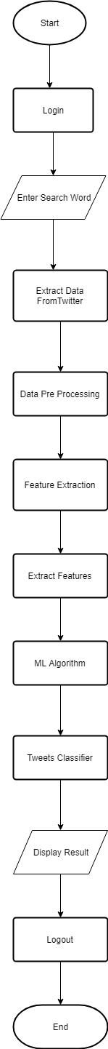
Figure 2.3 Flow chart
In this diagram, we first login with the valid login details i.e. username and password then we search the word that is to be searched. Afterword’s we extract the data or tweets from the twitter using twitter API, we then preprocess the data from raw data to understandable data.
From there we use feature extracting process in which we separate the data into its equivalent polarity i.e. positive, negative, and neutral. Feature extraction involves reducing the amount of resources required to describe a large set of data. When performing analysis of complex data one of the major problems stems from the number of variables involved. Analysis with a large number of variables generally requires a large amount of memory and computation power, also it may cause a classification algorithm to overfit to training samples and generalize poorly to new samples. Feature extraction is a general term for methods of constructing combinations of the variables to get around these problems while still describing the data with sufficient accuracy. Many machine learning practitioners believe that properly optimized feature extraction is the key to effective model construction. After extraction we separate the data into proper table and then proceed further.
After that we use the algorithm that we want to use in our project. Training data is the set of data used in an algorithm, training data means separating data into training and testing sets is an important part of evaluating data mining models. Typically, when you separate a data set into a training set and testing set, most of the data is used for training, and a smaller portion of the data is used for testing. In machine learning, the study and construction of algorithms that can learn from and make predictions on data is a common task. Such algorithms work by making data-driven predictions or decisions through building a mathematical model from input data. Then the tweet classifier classifies the tweets according to its polarity and the process ends.

3. Requirement Analysis and Planning

In requirements analysis encompasses those tasks that go into determining the needs or conditions to meet for a new or altered product or project, taking account of the possibly conflicting requirements of the various stakeholders, analysing, documenting, validating and managing software or system requirements. Project planning is part which relates to the use of schedules such as Gantt charts to plan and subsequently report progress within the project environment. Initially, the project scope is defined and the appropriate methods for completing the project are determined

Functional Requirement
Functional requirement are the functions or features that must be included in any system to satisfy the business needs and be acceptable to the users. Based on this, the functional requirements that the system must require are as follows:
• System should be able to process new tweets stored in database after retrieval
• System should be able to analyze data and classify each tweet polarity

Nonfunctional requirements

3.2.1 Performance
3.2.1.1 Real-Time: The software will provide up-to-date information, limited only by the rate of Twitter input.
3.2.1.2 System Resource Consumption: Resource consumption of this application should not reach an amount that renders the computer unusable. The system must be able to support multiple users. There’s no initial target user base but the system should be able to support many users and allow for future expansion to different social networks such as Facebook & Google+. The response time of the system must allow for all actions to be performed in real time, the results must be available for review instantly.

3.2.2 Reliability
The reliability of our system is predicted to be very high and critical for proper functioning of the overall system.The software will meet all of the functional requirements without any unexpected behavior. At no time should the output should display incorrect or outdated information without alerting the user to potential errors. The system must be available 24 hours a day 7 days a week as it may be used at any time, throughout many various locations to access all available options

3.2.3 Availability
The software will be available at all times for the users. The functionality of the software will depend on any external services such as internet access that are required.

System requirements
This section contains all of the functional and quality requirements of the system. It gives a detailed description of the system and all its features.

3.3.1 Hardware requirements
3.3.1.1: Since the application must run over the internet, all the hardware shall require to connect internet will be hardware interface for the system. As for e.g. Modem, WAN –
LAN, Ethernet Cross-Cable.

3.3.1.2: Screen resolution of at least 800X600 is required for proper and complete viewing of screens. Higher resolution will be accepted.

3.3.1.3: Processor: Intel i3 and above
Ram: 2GB
Hard Disk: 500 GB

3.3.2 Software requirements
3.3.2.1 Inputs The software will receive input from two sources. First, the user interface and second, the Twitter API. The user interface will supply the keywords and the analysis session duration, while the Twitter API will supply the Tweet text.
3.3.2.2 Outputs The output will portray the current mood of the Twitter community. If available, historical data will be displayed in a graph.
3.3.2.3 Operating System The software will run on the Windows operating system.

Project Planning

3.4.1 Timeline Project
The following tables give the project plan for phase 1 and 2 of the project:
PHASE 1
Table 0-1 Project Timeline Phase -1
Activity | Description | Effort in person weeks | Deliverable
Phase 1
P-01 | Information gathering | 2 week | Requirement Gathering
P-02 | Project analysis | 1 week | Existing System Study & Literature Survey
P-03 | Feasibility study | 3 weeks | Feasibility Study
P-03 | Documentation | 1 week | Proposal Report
P-04 | Designing | 3 weeks | Module description
P-05 | Project implementation | 4 weeks | Implementation of important modules
 | Total | 14 weeks

PHASE 2
Table 0-2 Project Timeline Phase - 2
Activity | Description | Effort in person weeks | Deliverable
Phase 2
P-01 | Detailed Design | 5 weeks | Documentation
P-02 | Complete Implementation and Integration | 5 weeks | Code and module of product release
P-03 | Testing and Bug fixing | 3 week | Test Report
P-04 | Release/Deployment | Included in above | Product Release
P-05 | Closure | One week | Documentation
 | Total | 14 weeks

3.4.2 Task distribution
Table 0-3 Task Distribution
GROUP MEMBERS NAME | POSITION OF EVERY MEMBER | TASK PERFORMED BY MEMBER
Jain Rajat Ashok | Team Leader | Analysis, Designing, Testing and Coding.
Kshatriya Sawan Ranjan | Team Member | Analysis, Coding, Designing, Testing
Dubey Arun Kumar Vyas | Team Member | Concept, Documentation, Testing,
Shukla Pratyush Suresh | Team Member | Documentation, Designing, Testing.

Analysis Modeling

In this chapter, all the aspects of the proposed system will be covered in the diagrammatic manner and provides the detailed manner of the system.

4.1 Behavioral Modeling
UML behavioural diagrams visualize, specify, construct, and document the dynamic aspects of a system. The behavioural diagrams are categorized as follows: use case diagrams, interaction diagrams, state–chart diagrams, and activity diagrams.

4.1.1 Use Case Diagram

Fig 4.1 shows Use-Case Diagram
- Tweet Collector will first login and will get tweets from twitter using Twitter API.
- Based on the tweets collected data extraction and data pre-processing will be done.
- After that algorithm will be applied to find emotion from tweets.
- Then after finding emotion the user who is using the model will be able to find whether the tweets are negative, positive or neutral.

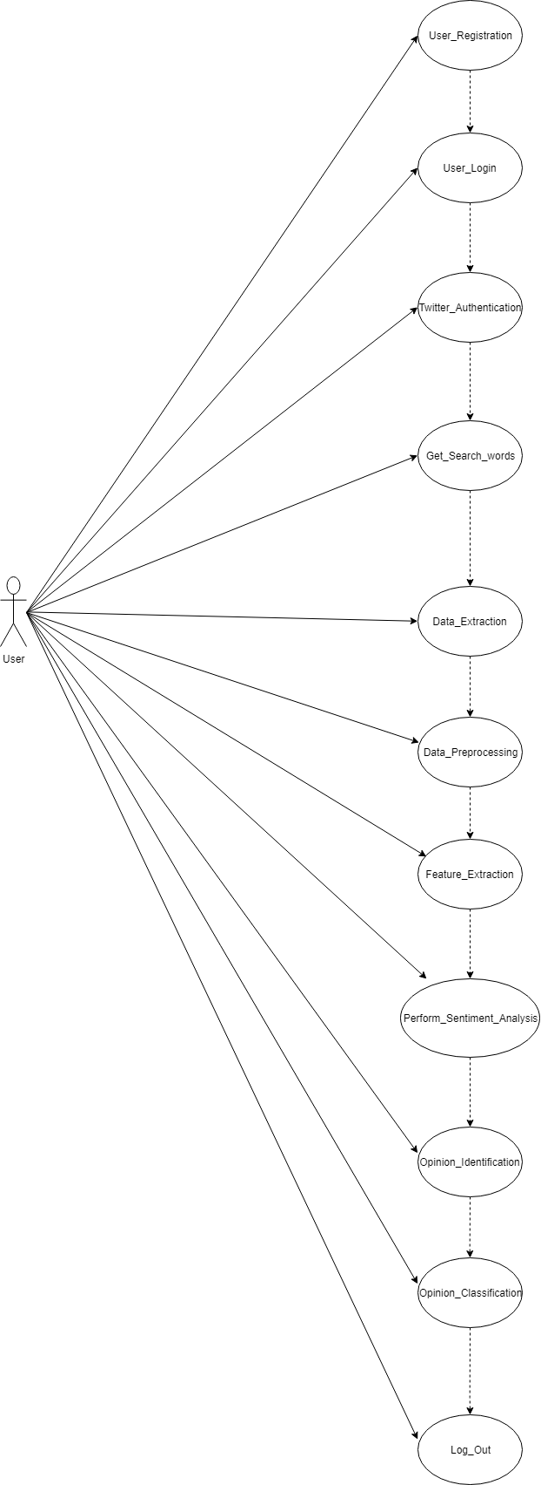
Figure 4.1 Use Case

4.1.2 Sequence Diagram

UML sequence diagrams are used to show how objects interact in a given situation. An important characteristic of a sequence diagram is that time passes from top to bottom: the interaction starts near the top of the diagram and ends at the bottom (i.e. Lower equals later).
Here in Figure 4.2, there is one entity User.
User will first login in web application which will be checked from database. User will then search tweets of topic they want and then that related tweets will be stored in database. After that data pre-processing and feature extraction will be done and their results will be stored in database. Then sentiment analysis will be performed and users will get the opinion when it is completed. After that user can logout.
The sequence diagram is shown below:
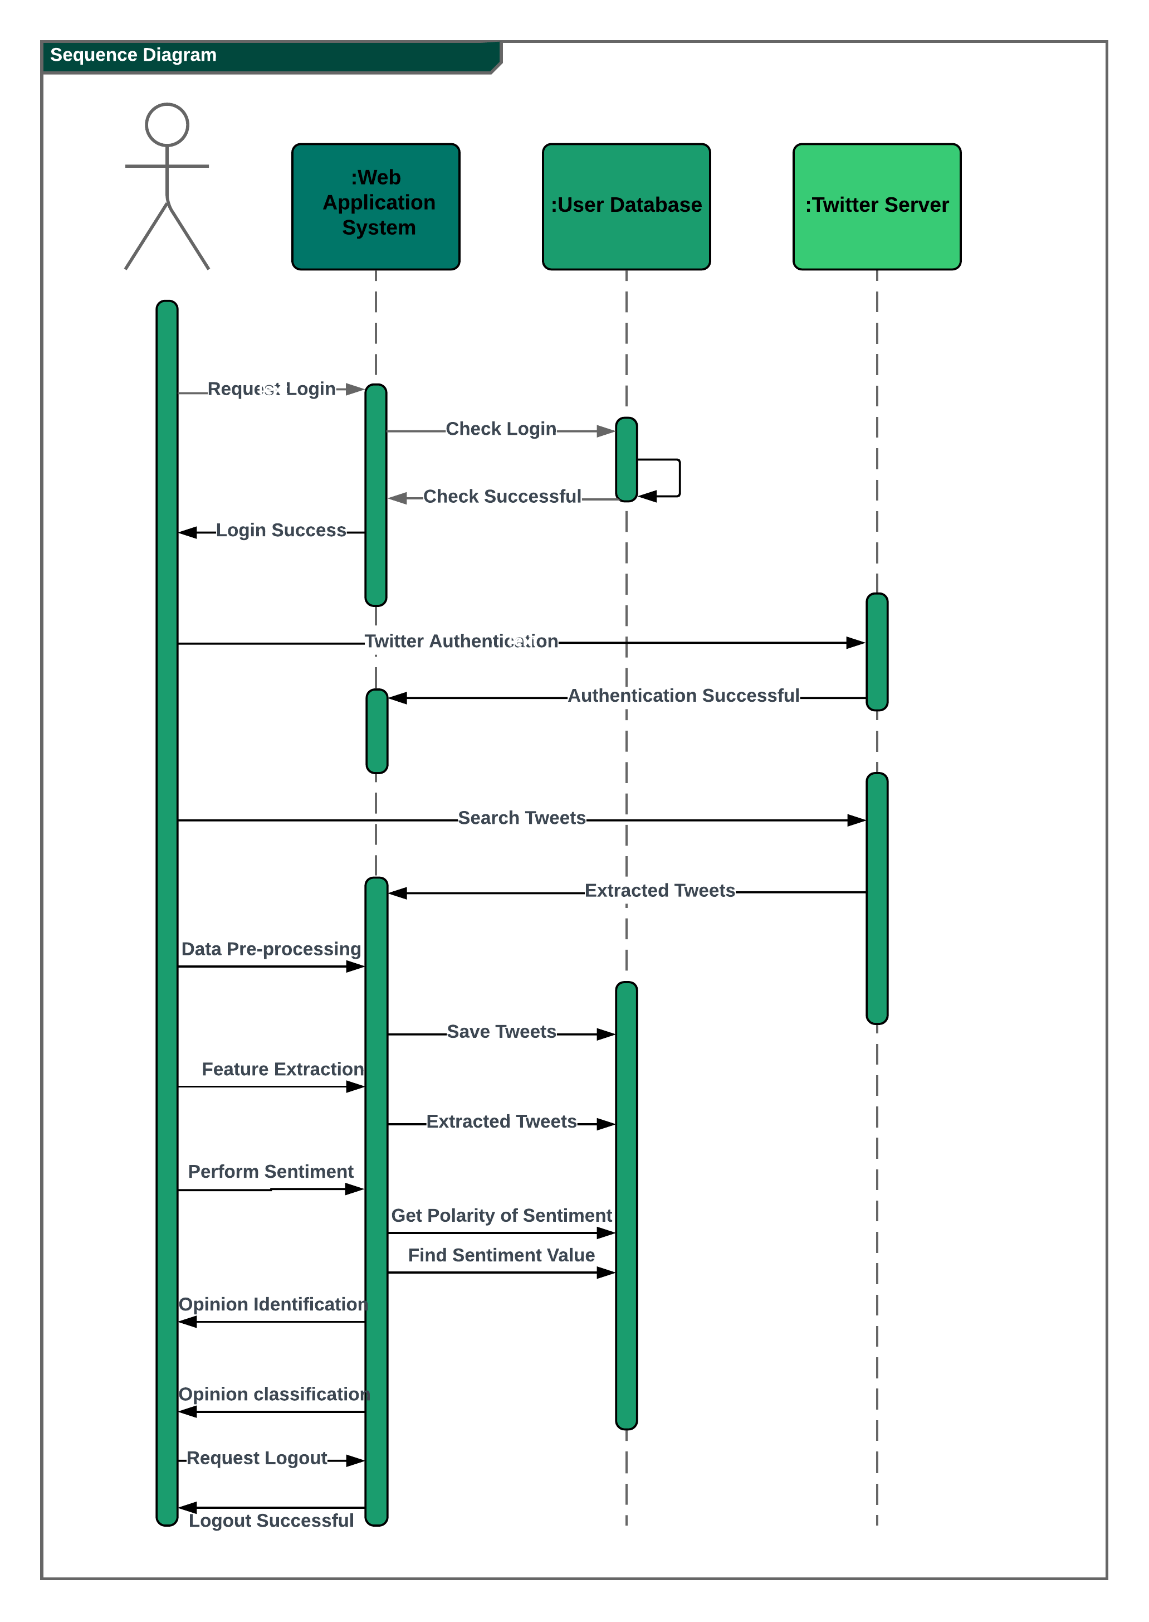
Figure 4.2 Sequence Diagram

4.1.3 Activity Diagram

It starts with starting point as shown in Figure 4.3, then the user will login which will be checked from database whether the entered username and password. Then the user will search word and after that data pre-processing and feature extraction will take place.
Based on that sentiment analysis will be done and once the user will get opinion identification then the user can logout.
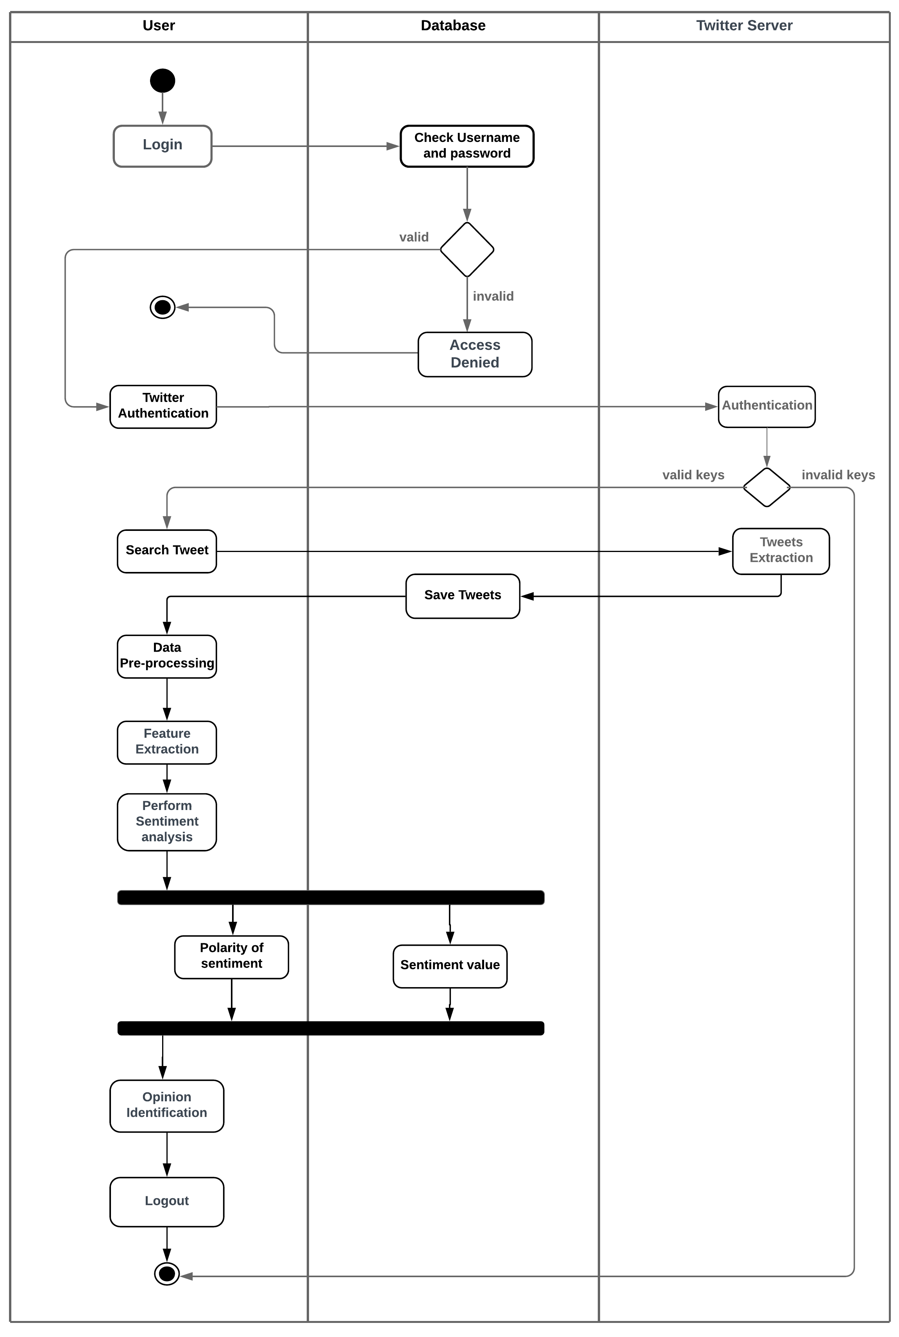
Fig 4.3 Activity Diagram

4.1.4 State Chart Diagram

Figure 4.4 represents various states that the system takes while processing. The foremost state is related to webcam which will start recording the video according to the timer when the timer is set. After the video is recorded the state is where the entire processing of the video takes place which will then lead to state where the system will calculate the drowsiness of the driver

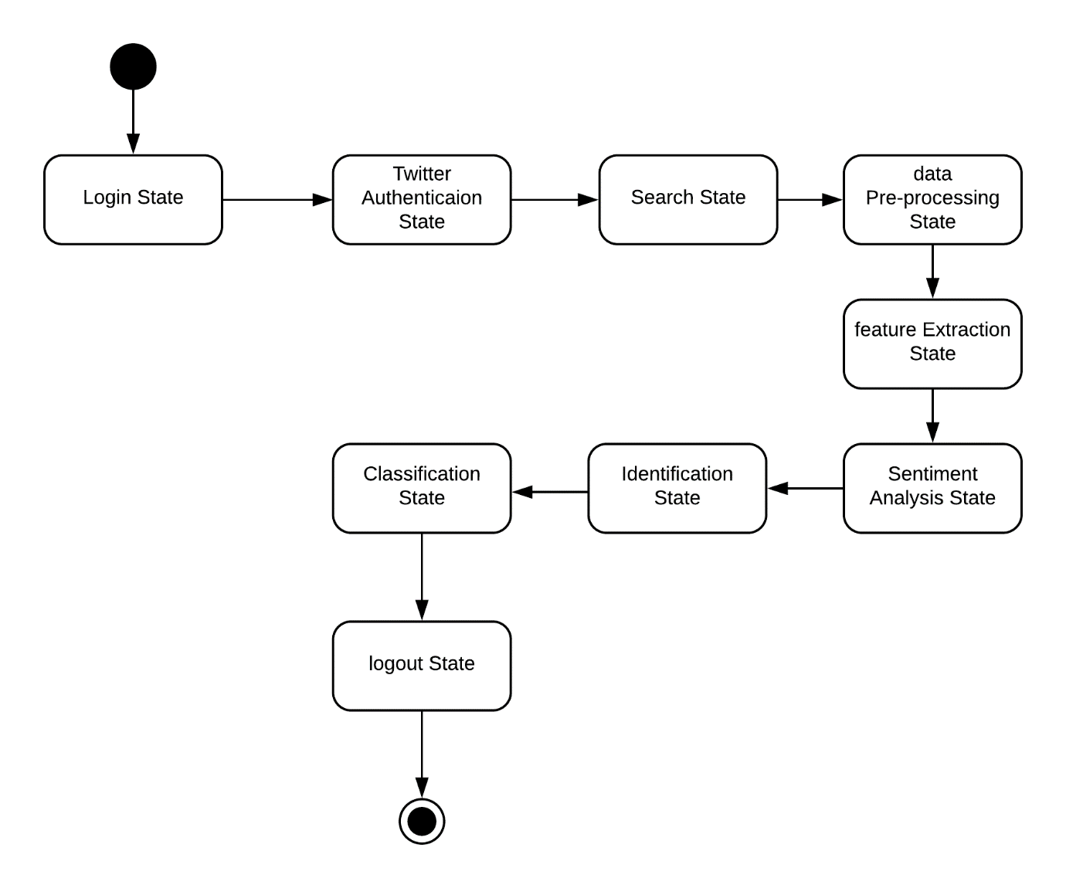
Figure 4.4 State Chart Diagram

4.2 Data Flow Diagram

4.2.1 DFD - Level 0
In Figure 4.5, there are various levels for emotion detection from tweets and emoticons. The level 0 indicates that the user logins into system and then search tweets topic which will be used for retrieving tweets and for data pre-processing and feature extraction. When sentiment analysis is applied the user will get back its result.

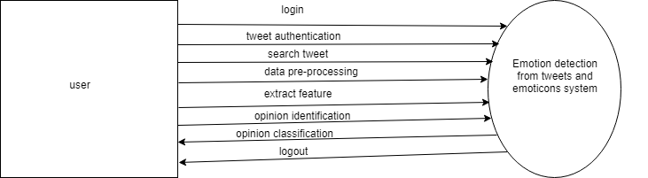

Figure 4.5 DFD level 0

4.2.2 DFD - Level 1
Figure 4.6 contains next level i.e level 1 of dfd contains 4 processes namely Login, data pre-processing, feature extraction, sentiment analysis. Login Process handles the Login Module (user). Data pre-processing handles search tweets which is stored in database once the tweets are retrieved. Based on the data pre-processing database feature extraction is done and stored in database through which sentiment analysis is done which users gets.
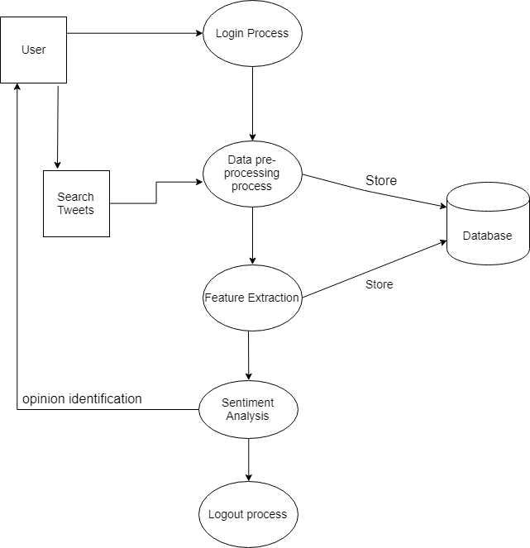
Figure 4.6 DFD level 1

4.2.3 DFD - Level 2

In Figure 4.7, the0 level 2 of dfd explains the Data pre-processing and Sentiment analysis process in detail. The first process data pre-processing, in this user search tweets topic which will be retrieved from real time tweets data and based on that data pre-processing process is done which is cleaned and stored in database.
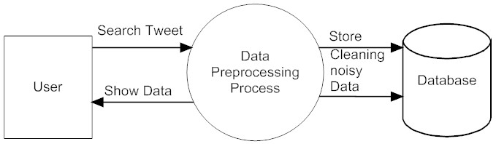

Figure 4.7 DFD level 2.1

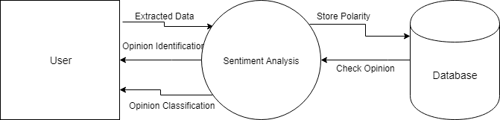

Figure 4.7 DFD level 2.2

The second process Sentiment analysis process, in this extracted data is passed and sentiment analysis is done which will then store polarity of tweets in database and then user can know about opinion of tweets through opinion identification.

4.3Database Design

4.3.1 ER Diagram

In Figure 4.5, ER diagram for emotion detection from tweets and emoticons is shown. ER stands for Entity Relationship. This diagram indicates various entities involved and how these entities are related to each other. The entities involved in our system are Registration, Login, Tweets, Tweets sentiment value and Tweets polarity. The communication between these entities is shown in the figure below.
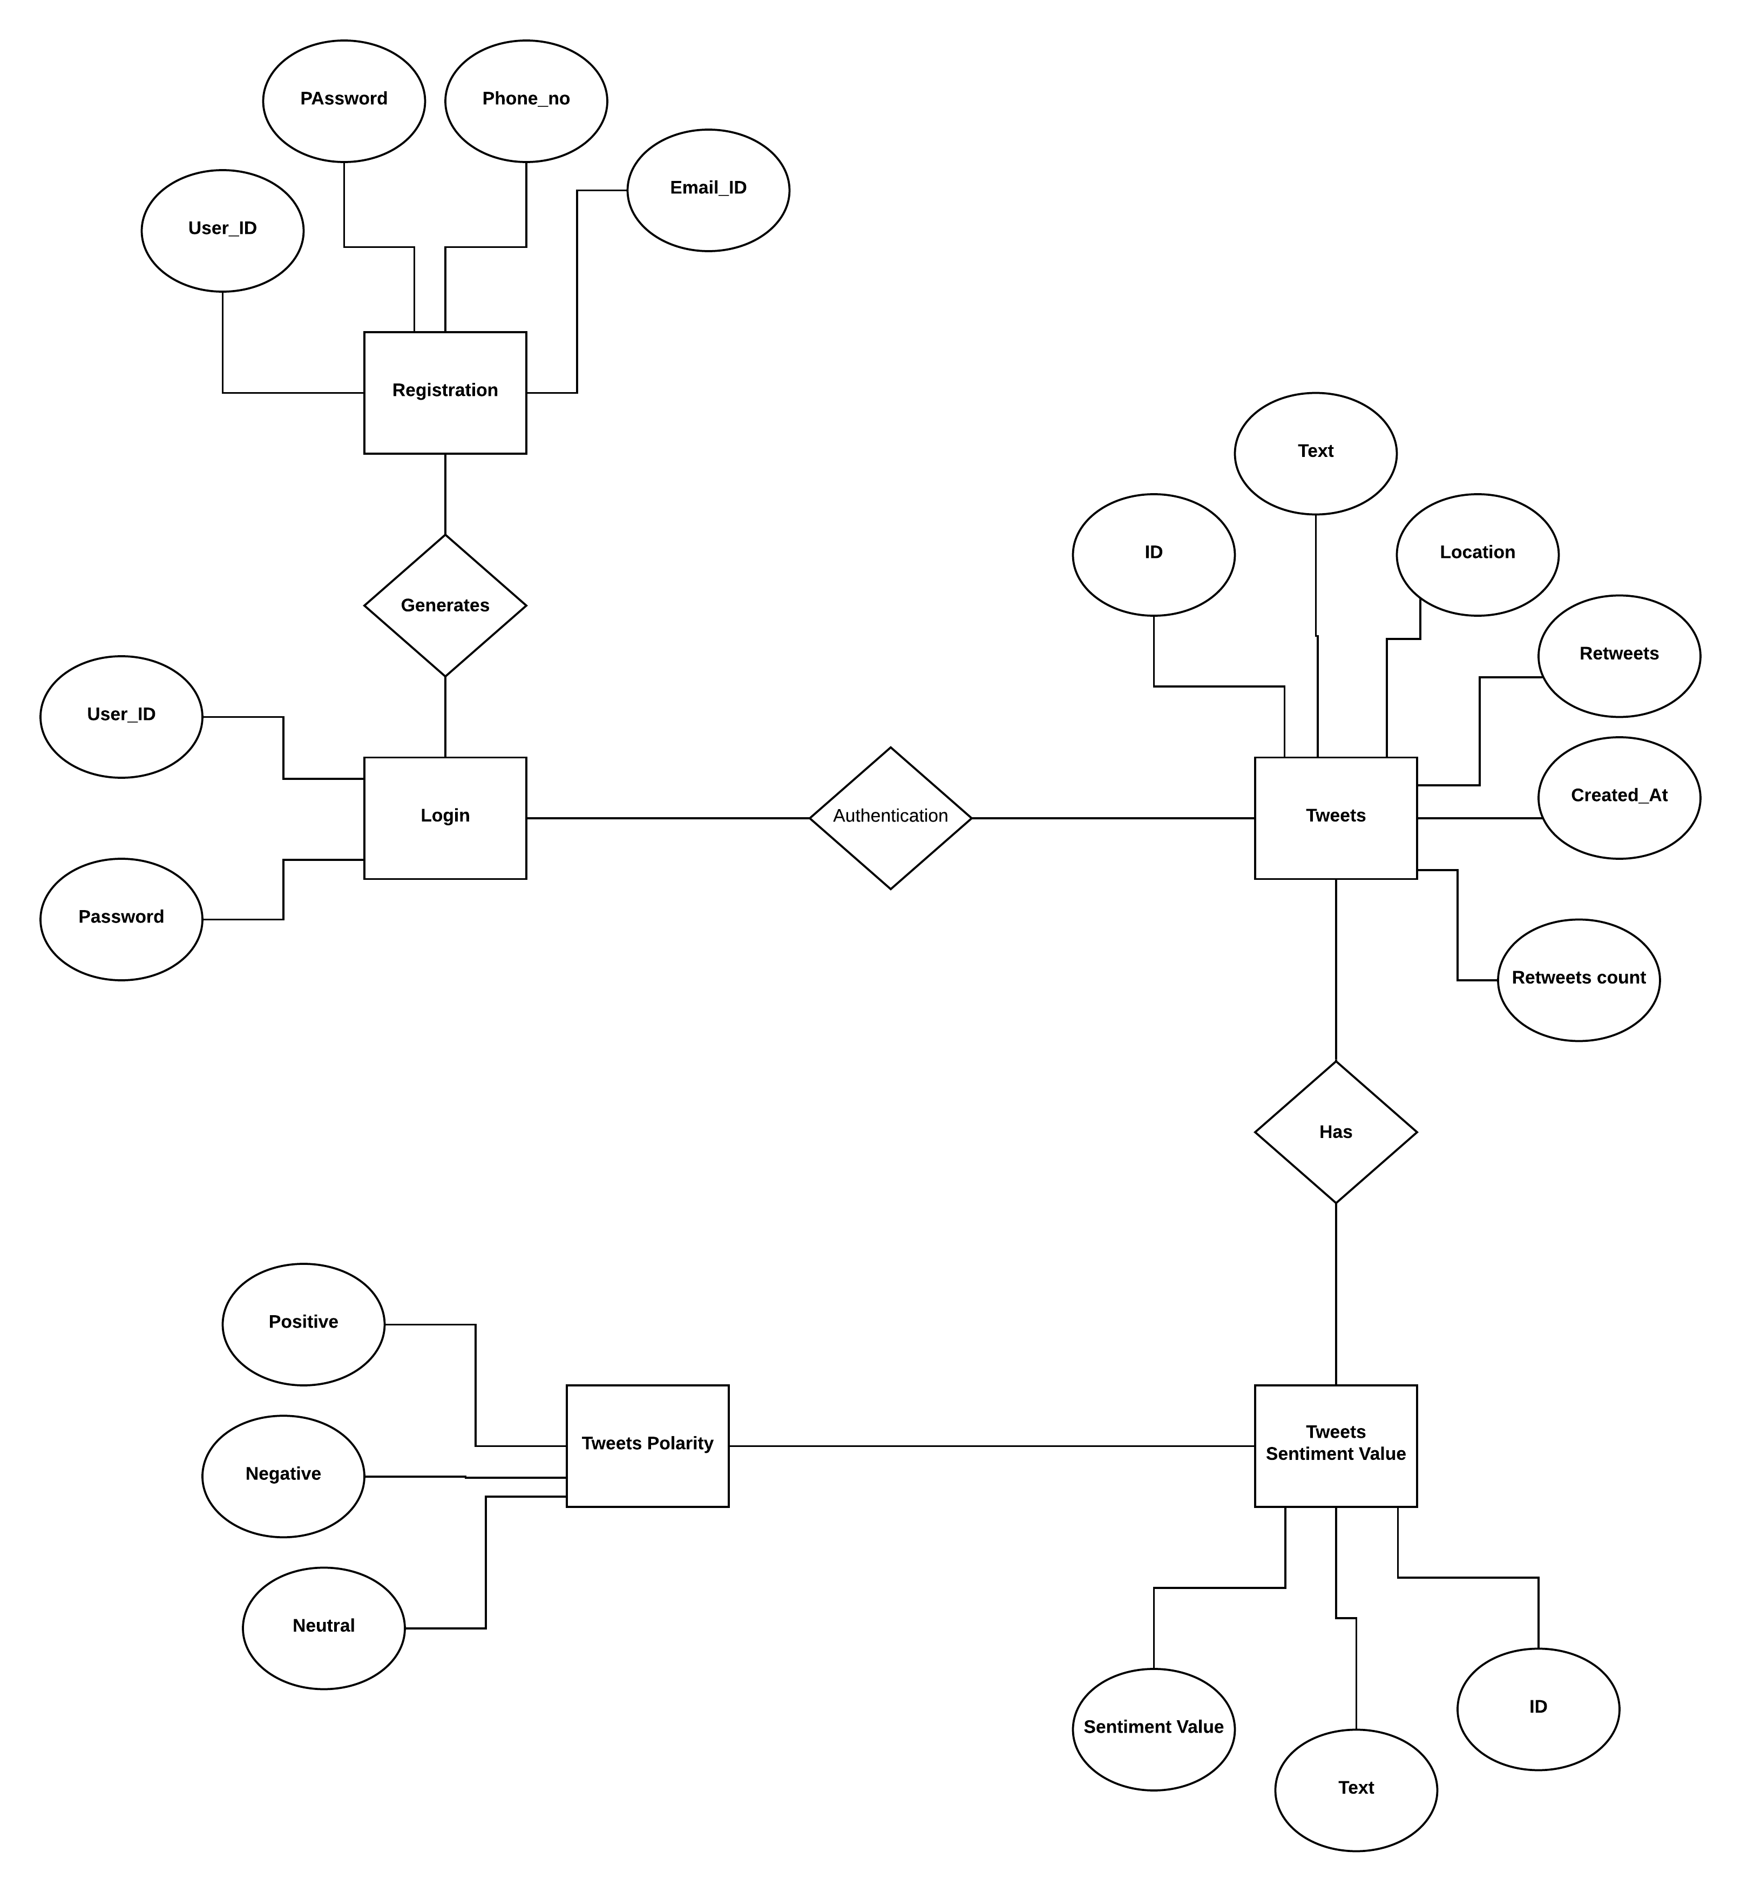

Figure 4.5 ER Diagram

5. System Design
Design will elaborate the process of describing, organising and structuring the components of the system both at the architectural level and at the detailed level.

5.1 Application Architecture
The Figure 5.1 shows block diagram of the system. The sentences that represent observations or attitude that is expressed as positive or negative are called as sentiments. Shown in Fig.5.1. describes an overall system design of twitter sentiment analysis. The users post their tweets in twitter. These tweets are then extracted in real time using twitter API in the form of raw data which are then saved in database.
The raw dataset is converted into target dataset through Data Pre-Processing and Feature Extraction. The features of the words are selected and then machine learning techniques are applied on extracted features to classify them into its sentiment polarity that is namely positive, negative or neutral.

Raw Data
Data Extraction
Authentication
Twitter API

Feature
Extraction
Target Database
Data Pre-Processing

Positive
Tweets
Classifier
Fig.1
Algorithm
Negative

Neutral

Figure 5.1 Architecture

5.2Class Diagram
The class diagram is a static diagram. It represents the static view of an application. Class diagram is not only used for visualizing, describing and documenting different aspects of a system but also for constructing executable code of the software application.
The class diagram describes the attributes and operations of a class and also the constraints imposed on the system. The class diagrams are widely used in the modeling of object oriented systems because they are the only UML diagrams which can be mapped directly with object oriented languages.
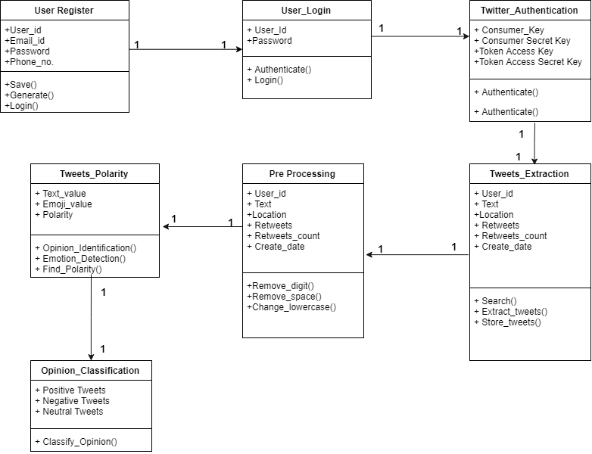
Fig.5.2 Class Diagram

5.3Object Diagram

Figure 4.6 shows a static view of the structure of twitter sentiment analysis. Here as we can see, there are various objects R1, L1, T1, P1 are few examples to be named.

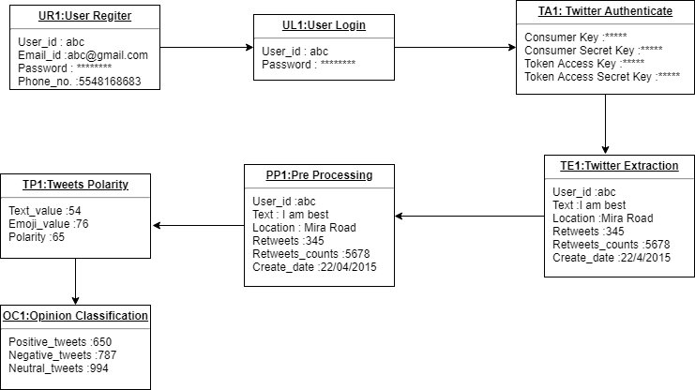
Figure 5.3 Object diagram

There are various attributes associated with each object, For example, for the object R1, there are attributes like save (), GenerateId (), and capture login (). Similarly there are attributes for other objects as well. Here the object diagram is used to render a set of objects and their relationships as an instance.

5.4 Collaboration Diagram

From the name Interaction it is clear that the diagram is used to describe some type of interactions among the different elements in the model. So this interaction is a part of dynamic behaviour of the system. This interactive behaviour is represented in UML by two diagrams known as Sequence diagram and Collaboration diagram. The basic purposes of both the diagrams are similar. The purpose of interaction diagram is:
To capture the dynamic behaviour of a system. To describe the message flow in the system. To describe the structural organization of the objects. To describe the interaction among objects.

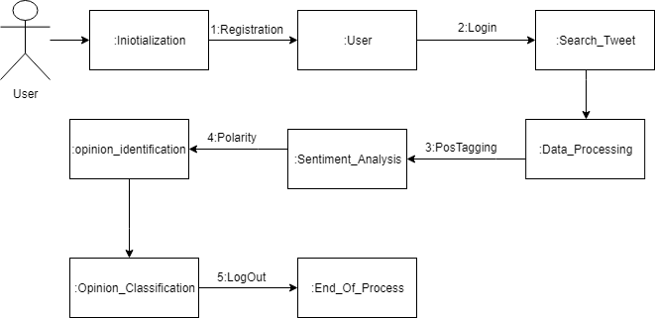
Fig 5.4 Collaboration diagram

5.5 Component Diagram

Component diagram is a special kind of diagram in UML. It does not describe the functionality of the system but it describes the components used to make those functionalities. Component diagrams are used during the implementation phase of an application. However, it is prepared well in advance to visualize the implementation details.
Here fig 5.5 component diagram shown below
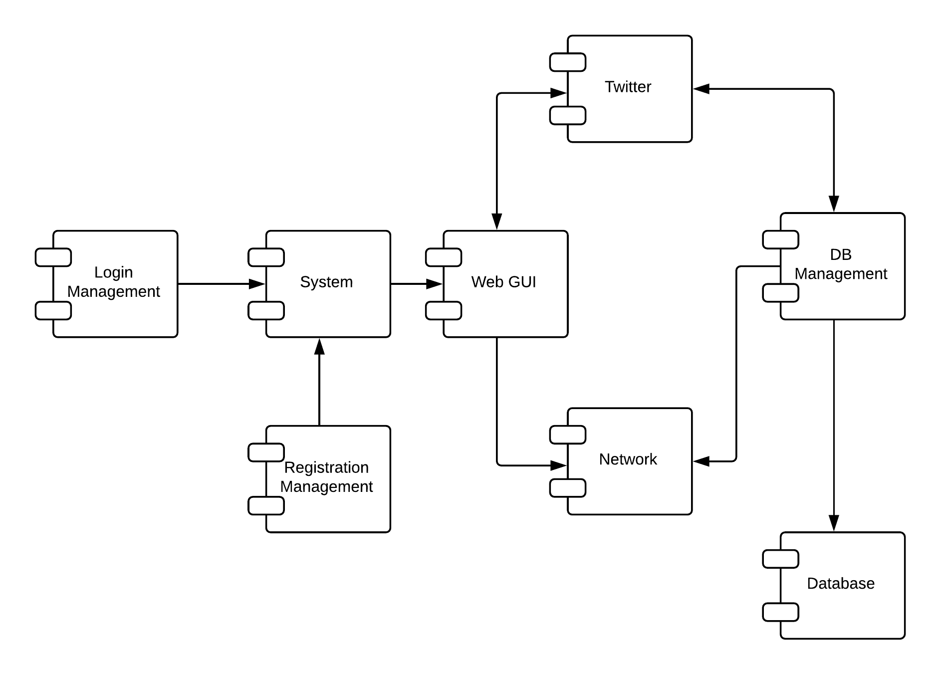

Fig. 5.5 Component Diagram

5.6 Deployment Diagram

The name Deployment itself describes the purpose of the diagram. Deployment diagrams are used for describing the hardware components where software components are deployed. Component diagrams and deployment diagrams are closely related.

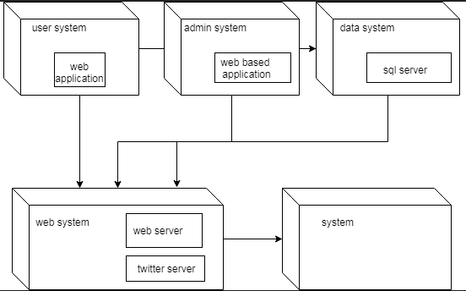

Fig. 5.6 Deployment Diagram

5.7 Graphical User Interface
In fig 5.7.1 shows the registration window which the users need to fill before using our model Emotion Detection from tweets.
All the information of the users will be then saved in database.
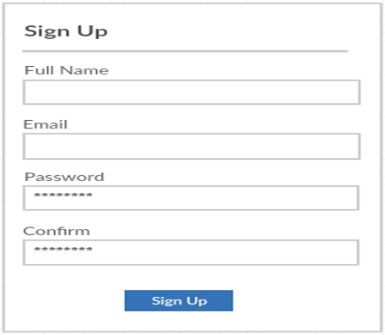
Fig 5.7.1 Registration Window

Once the users information is stored in database, Users need to login with ID given to them.
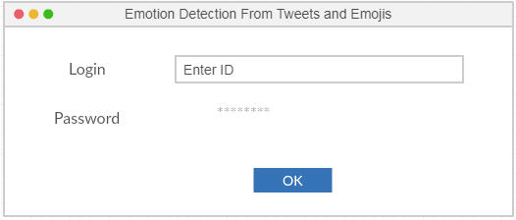

Fig 5.7.2 Login Window

Figure 5.7.3 shows the interface.Main Screen
This is the main screen of the program. It has all the options that the user can select by pressing the appropriate button.
Enter Topic
First the user needs to enter the topic on which they want real time tweets to be downloaded.
They can enter topic name in Enter Topic option in screen.

Download Real time tweets
Once the user enters the topic they must download the real time tweets by pressing the download real time tweets in screen which will download all tweets related to search topic.

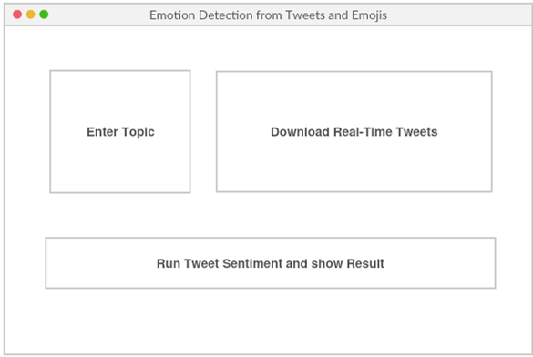
Fig 5.7.3 GUI

Run Tweet Sentiment and show Result
After the Twitter stream has been downloaded and saved to the database, we can proceed to find the sentiments of the Tweets. Press the Run Tweet Sentiment button to start this process. This will open a new window with the results displayed in a table or chart.

6. Implementation
This chapter will give all the implementation details and methods used to implement the application in brief.

6.1 Using Twitter4j
Twitter4J is an open source Java library, which provides a convenient way for accessing the Twitter API.
Simply put, here’s how we can interact with the Twitter API; we can:
- Post a tweet
- Get timeline of a user, with a list of latest tweets
- Send and receive direct messages
- Search for tweets and much more
This library ensures that we can easily do these operations, and it also ensures the security and privacy of a user – for which we naturally need to have OAuth credentials configured in our app as shown in fig 6.1

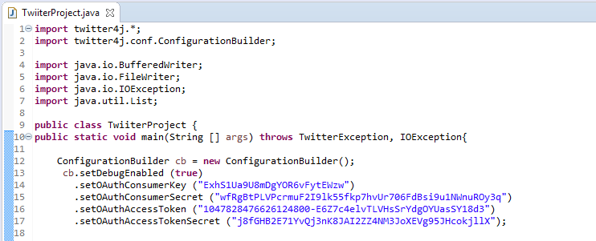
Figure 6.1

6.2 Extracting Tweets on Specific Topic

The Sample screen shot of this module is shown in Figure 6.2.
A TwitterFactory class is used which is a factory class for Twitter.
An instance of this class is completely thread safe and can be re-used and used concurrently.
Then we search for specific topic for which we want to extract real time tweets in Query and that topic is search using twitter.search(query);
StringBuilder is used since strings are immutable in java, so for editing a string we can perform same by converting it to string builder.
The Extracted Real-Time tweets are then stored in Text file.

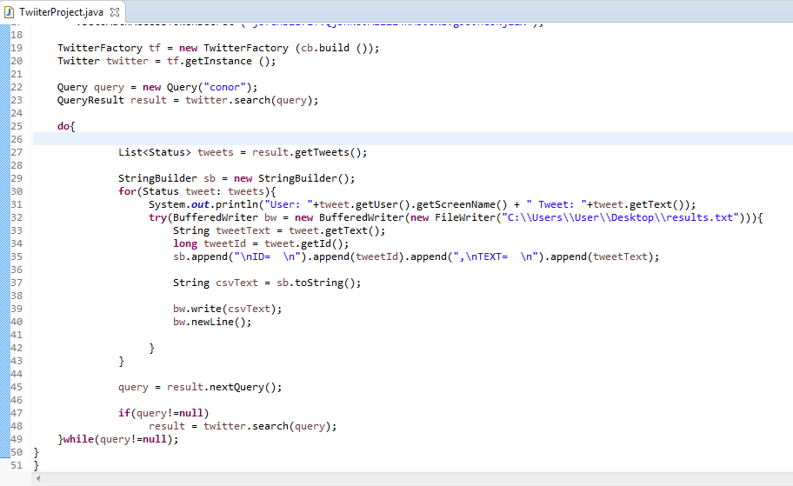
Figure 6.2

7. Results

This chapter contains results of final product module wise. It contains snapshots of different modules of the system.

7.1 Extracting Real Time Tweets

In Figure 7.1 is the snapshot of the results generated by our program which is real time tweets and is saved in Txt file .

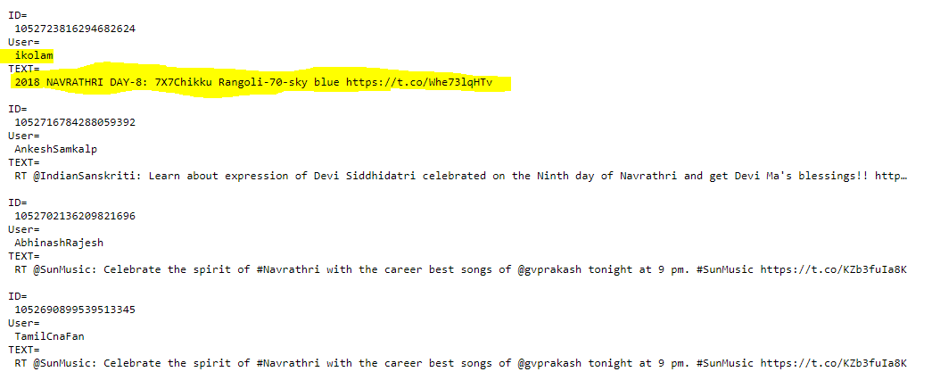

Figure 7.1: Extracted Real time Tweets

7.2 Official Twitter Screenshot of Tweet

In Figure 7.2 screenshot of official twitter page is shown to verify that our model downloads the same tweets which user’s had tweeted in real time.

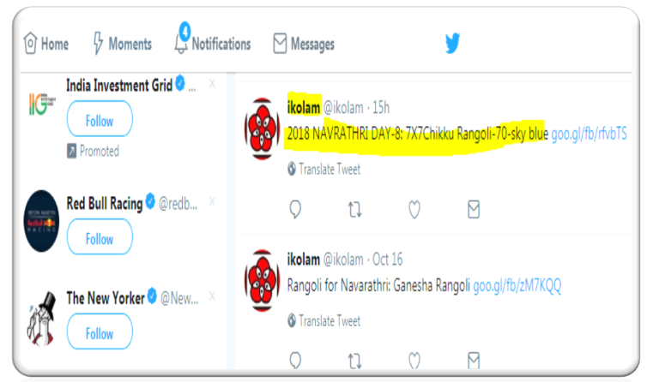

Figure 7.2 Official Twitter Screenshot of Tweet

8. Conclusion

Prototype emotion detection from tweets system will be developed using machine learning techniques. The models will be trained and validated against a test dataset. We apply machine learning techniques to solve twitter sentiment analysis problem. The proposed work can also be used for future work. Sentiment Analysis is still a difficult and Complex problem in computer Science. Sentiments are express by Humans in Different Ways. The objective of this work is to create a system for finding the emotion from tweets and emoticons for users in a user friendly way.

9. References

[1] Sameesksha Shrivastava1 , Dr. Pramod S. Nair ,“Mood Prediction On Tweets Using Classification Algorithm”, International Journal of Science and Research (IJSR) 2015

[2] Akshi Kumar , Prakhar Dogra and Vikrant Dabas ,“Emotion Analysis of Twitter using Opinion Mining”, IEEE System, 2015 Eighth International Conference on Contemporary Computing (IC3)

[3] Abu Zonayed Riyadh, Nasif Alvi, Kamrul Hasan Talukder, “Exploring human emotion via Twitter”, IEEE System, 2017 20th International Conference of Computer and Information Technology (ICCIT)

[4] Akshi Kumar and Teeja Mary Sebastian, “Sentiment Analysis on Twitter”, IEEE System, IJCSI International Journal of Computer Science Issues, Vol. 9, Issue 4, No 3, July 2012

[5] Seyed-Ali Bahrainian, Andreas Dengel ,“Sentiment Analysis and Summarization of Twitter Data” , IEEE System, 2013 IEEE 16th International Conference on Computational Science and Engineering

[6] M S Neethu,R Rajasree, “Sentiment Analysis in Twitter using Machine Learning Techniques” IEEE System, 2013 Fourth International Conference on Computing, Communications and Networking Technologies (ICCCNT)

[7] Brett Duncan and Yanqing Zhang “Neural Networks for Sentiment Analysis on Twitter”, IEEE System, 2015 IEEE 14th International Conference on Cognitive Informatics & Cognitive Computing (ICCI*CC)

[8] Olivier Janssens, Maarten Slembrouck, Steven Verstockt3, Sofie Van Hoecke1, Rik Van de Walle “Real-time Emotion Classification of Tweets” , IEEE System, 2013 IEEE/ACM International Conference on Advances in Social Networks Analysis and Mining

[9] Sandeep. J. Patil, Prashant. C. Harne, Pravin.K.Patil, “Study and Review of Sentiment Analysis for Social Networks using Classification Algorithm”, IEEE System, International Conference on Global Trends in Engineering, Technology and Management (ICGTETM-2016)

[10] Dwi Aji Kurniawan, Sunu Wibirama , Noor Akhmad Setiawan ,“Real-time Traffic Classification with Twitter Data Mining”, IEEE System, 2016 8th International Conference on Information Technology and Electrical Engineering (ICITEE)

